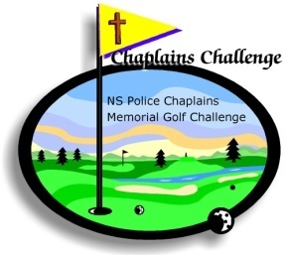

2018 Nova Scotia Police Chaplains

# Memorial Golf Tournament

It is more Blessed to Give than to Receive

Office Use Office Use

Team # _____ Date Received _________

September 18, 2018 8:45 AM

Penn Hills Golf Club

REGISTRATION FORM

PLEASE PRINT

Team Members:

1 _______________________ Email ______________________________

2 _______________________ Email ______________________________

3 _______________________ Email ______________________________

4 _______________________ Email ______________________________

TEAM CONTACT PERSON: __________________________________

HOME TELEPHONE __________________________________

CELL # __________________________________

FEE MUST BE PAID IN FULL WHEN REGISTRATION IS SUBMITTED

$ 100.00 CHEQUE, MONEY ORDER PER PLAYER PAYABLE "CHAPLAINS

CHALLENGE"

CALL FOR PICKUP WITH PAYMENT TO:

Richard Irving

Email: r.irving@ns.sympatico.ca

902-489-3774